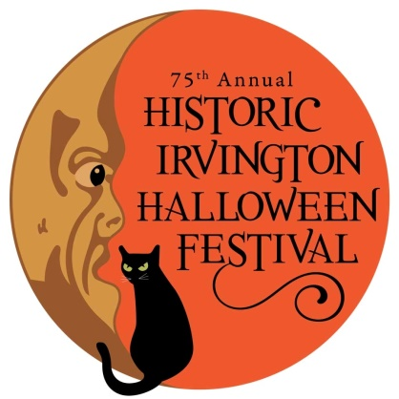

2021 COSTUME CONTEST RULES & DETAILS

Description:
The Annual Historic Irvington Halloween Festival Costume Contest is fun for everyone! Show off your creativity and have a great time with the potential to win some fabulous prizes.

Location: Parking Lot at Irvington Branch of the Indianapolis Public Library 5625 E. Washington St. (South end of parking lot)

Entry Fee: FREE

Eligibility:
- No age limit – see entry categories below
- This is a family-friendly event. NO Political, Religious, Overtly Sexual or Excessively Violent costumes will be allowed. The Historic Irvington Halloween Festival reserves the right NOT to accept any costume that is deemed to be inappropriate for all ages. etc.

Important Dates:
- Contest will be held during the Historic Irvington Halloween Festival on Saturday, October 30th.
- Advance Online Registration is encouraged! October 4 –27th at 3:00pm
  - https://tinyurl.com/irv-costume-2021
- In Person Registration on Saturday October 30th from 11:00am-Noon ONLY
- Late Registrations will not be accepted.

Rules & Format:
- Age Groups:
  - 0-5 Years
  - 6-12 Years
  - 13-17 Years
  - Adult (18+)
  - Groups (2 or more of any age)

- Entry Categories:
  - Handmade/Original - Use your own materials and creativity to design an artistic, unique, original masterpiece.
  - Scary - Do your best to scare the judges with your most frightening creation (but not TOO scary)
  - Popular Culture - Examples of “pop culture” come from a variety of sources and influences such as Music, Television, Advertising and Sports.

Judging Process:
- A panel of judges will be on site on Saturday October 30th to assess costumes. All contestants MUST be present in the judging area at the time allotted for your group to be eligible for awards. Photos will be taken and posted on the Historic Irvington Halloween Festival website and Facebook page.
- Judging will begin promptly at 12:30pm with the following schedule:
  - 12:30pm – Ages 0-5 years
  - 1:00pm – 6-12 years
  - 1:30pm – 13-17 years
  - 2:00pm – Adults
  - 2:45pm – Groups (2 or more of any age)

Awards:
- First, Second, and Third place winners in all categories as determined by the Judges will receive a ribbon
- First place winners as determined by the Judges will advance to the Directors Choice Round
  - The Director will choose the top entry from the Adult or Group Category for the GRAND PRIZE – To Be Determined

Marty Powell Costume Parade and Award Ceremony:
- All Costume Contest participants are encouraged to be a part of the Parade!
- The Parade will begin at 4:00pm, near the Main Stage and proceed down Audubon Street.
- Winners will be announced, and prizes awarded from the Main Stage (Washington and Audubon) at the end of the parade.

Photo Release: All Costume Contest participants must give permission to the Historic Irvington Community Council & the Historic Irvington Halloween Festival to use a photograph of you and/or your child for promotional use. If you are under 18 years of age, a parent or guardian must give their consent. If a parent or guardian is not present, you may enter the contest but a photo will not be taken.

If you have any questions, please email: irvingtonhalloweenfestival@gmail.com

